 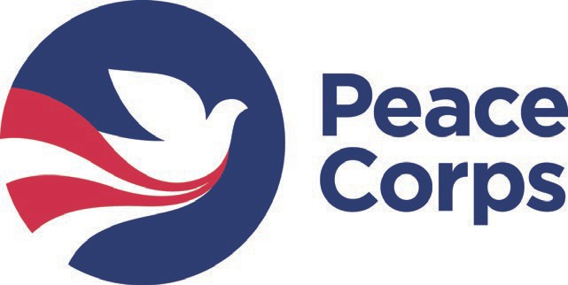

Name:

Student ID:

Date:

Phone: Email:

Expected Graduation (month and year): Cumulative GPA:

1. Training and experience in a specific [work sector](https://www.peacecorps.gov/volunteer/what-volunteers-do/)

#### Please check the box of the sector in which you would like to serve:

* + Education
  + Health
  + Environment
  + Agriculture
* Youth in Development
* Community Economic Development

*Note: Actual Peace Corps assignments are based on local needs, and thus may or may not align seamlessly with your qualifications. Flexibility is key to the Peace Corps experience!*

1. **Coursework. List the number and name of 3 courses in this same sector that you plan to take, and the semester in which you plan to take them** (it is fine if you’ve already taken them).

*Note: The courses you include on this application may change, but it’s good to have a plan.*

* 1. Course:
  2. Course:
  3. Course:

Semester and year: Semester and year: Semester and year:

1. **Hands-on experience in that same sector (must total at least 50 hours). Describe what you plan to do:**

## Foreign language skills

**Requirements depend upon desired Peace Corps volunteer placement site**. (1) Latin America/ *Spanish-speaking countries*→ two Spanish courses (at least Level IIII). (2) West Africa/ *French- speaking countries*→ one French course (at least Level II). (3) *Everywhere else*→ no explicit requirements, but language skills are a plus.

#### If you intend to learn a foreign language, please list which one:

**List the top 2 foreign language courses you plan to take:**

Course 1: Semester and year:

Course 2: Semester and year:

*Or describe your alternative learning process (e.g., native speaker):*

## Intercultural competence

#### List the number and name of the three courses you plan to take:

1. Course: Semester and year:

2. Course: Semester and year:

3. Course: Semester and year:

## Professional and leadership development

1. **Professional resume feedback:** When do you plan to meet with Academic Career Advising Center for a one-on-one resume review? Month and year:
2. **Professional interview prep:** When do you plan to meet with Academic Career Advising Center for an interview workshop? Month and year:

#### Describe a leadership experience that you intend to pursue:

*For example, leading a work or volunteer project, serving on the executive board of a student organization, or organizing a big campus event.*

Signature of Student Date

Signature of Peace Corps Prep Coordinator Date

#### Student Name: University: PC Prep Coordinator:

**EXIT CHECKLIST**

Below are the Peace Corps Prep certification requirements. If you apply to Peace Corps, please *scan and attach this signed form to your application with the name “PC Prep Checklist.”* If you apply to Peace Corps before completing a requirement below, write: “[Activity]: planned [month/year].”

## Training and experience in a specific [work sector](https://www.peacecorps.gov/volunteer/what-volunteers-do/)

#### Please check the box of the sector in which you have prepared yourself to serve:

* + Education
  + Health
  + Environment
  + Agriculture
* Youth in Development
* Community Economic Development

#### Coursework. List the 3 highest approved sector-aligned course #s and titles you took:

1.

2.

3.

1. **Hands-on experience in that same sector. Total Hours** (must be at least 50)**: Description of experience:**

## Foreign language skills

Requirements depend upon desired Peace Corps volunteer placement site. (1) *Spanish-speaking countries*→ two Spanish courses (at least Level IV). (2) *French-speaking countries*→ a French courses (at least Level II). (3) *Everywhere else*→ no explicit requirements, but language skills are a plus.

#### Language:

1.

#### List your 2 highest level course #s and titles:

2.

Or describe your alternative learning process (e.g., native speaker):

## Intercultural competence

#### List your 3 approved courses/experiences that bolstered your intercultural competence:

1.

2.

3.

## Professional and leadership development

1. **Professional resume feedback:**  Yes  No Date: Where:
2. **Professional interview prep:**  Yes  No Date: Where:
3. **Demonstrated leadership experiences** (i.e., student orgs, work, volunteer, etc.) **Describe:**

Signature of Student Date Signature of PC Prep Coordinator Date

**RELEASE OF INFORMATION FORM**

**Appendix F:** Release of Information Form

With your approval, the Cal Poly Humboldt Peace Corps Preparatory (PC Prep) program will release information on a regular basis to the Peace Corps, including details about the participants in this program and other relevant data that help the Peace Corps evaluate the effectiveness of PC Prep. These educational records are subject to the Family Educational Rights and Privacy Act (FERPA), a Federal law designed to protect the privacy of a student’s educational records. This Act prohibits college officials from disclosing any records, including grade reports, academic standings, transcripts of records, or any other records, which contain information directly related to the student and from which the student can be individually identified without the student’s consent. Consistent with FERPA guidelines, Cal Poly Humboldt will not release records related to your performance in the PC Prep program, other than those enumerated in this disclosure agreement.

I hereby permit Cal Poly to disclose personally identifiable information to Peace Corps regarding my participation in the PC Prep program for the purposes of evaluating PC Prep. This information will be limited to my name, date of admission to PC Prep, the coursework and other activities I pursued to satisfy PC Prep requirements, date of graduation, and whether I successfully completed the PC Prep upon graduation. If I do not ultimately enter the Peace Corps, Cal Poly Humboldt may report post-graduation career information to the extent that Cal Poly Humboldt has that information.

Student Name (printed)

Student Signature

Date